Test Plan For Incoming ISO Orders (SEDL 8866)

Session: W_MAIN

Disable the Linkage state for a Class (e.g. AAPL)

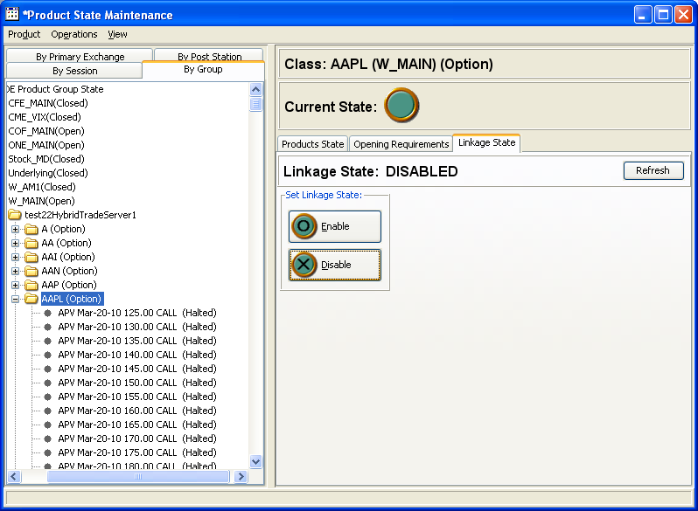

- Enter a Quote 1 x 1.00 – 1.20 x 100
- Enter customer Buy SWEEP Contingency Order 100@1.20
- Verify the incoming SWEEP (ISO) orders get traded against the quote.
- Verify the fill report for the Order and Quote.

